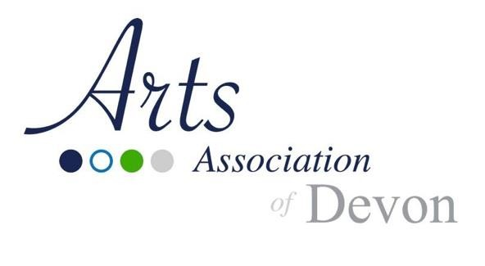
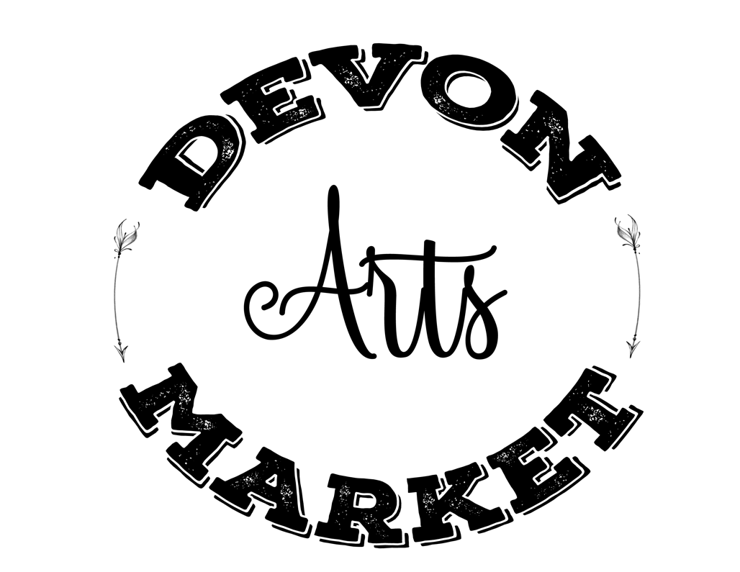

20
2
6

Monthly

Vendor

Application

February 8
,
2026

–

December
13
,
2026
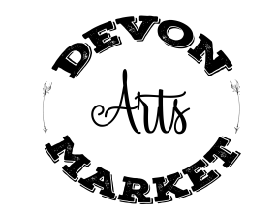 2026 Indoor Monthly Vendor Application revised Apr 2026

We reserve the right to limit market size and reject applications for any reason. Decisions of the Arts Market Committee are final. You will be notified in writing of your acceptance into the market (by email and if you do not have an email address, by post).

PROSPECTIVE MONTHLY INDOOR VENDOR
APPLICATION FORM

Please fill out the following information:
Renewal
New Vendor
(photos not required)

Vendor Business Name:

Personal Name:

Address:

City: Postal Code:

Main Phone: Cell Phone:

Alternate Phone:

Email: Website:

Facebook: Twitter:

Number of 8 ft tables desired:

Payment Method: Cash / Cheque Number / E-Transfer__________ /

Detailed Product Description (General description of wares. Only handcrafted items will be considered for approval.) Please include photos of typical items with application:
_
_

Please choose the market dates that you would like to attend for the 2026 season:

February 8 March 8 April 12 May 10
June 7 July 12 August 9 September 13
October 4 November 8 December 13

Please return the completed application to the Arts Market. You can mail, or email your application to:

Arts Association of Devon,
#9, 20 Haven Ave., Devon, AB T9G 2B9
Phone: 780-729-4932 | Email: ArtsDevon@gmail.com

Devon Arts Market Application Quick Checklist:

Application Form

Market Rules and Regulations duly initialed

Signed Waiver

Fee to secure committed bookings

Complete Description with Photos of Items (Not necessary for renewals)

Congratulations! You have completed the application process to participate in the 2026 Devon
Arts Market. All applications will be reviewed by our Arts Market Committee and / or Arts Association Executive. If you are selected, you will receive a confirmation package by mail and/or email. Depending on the number of applications we receive, approval times will vary for vendors.

Devon Arts Market Terms and Conditions
Notice to Vendors: You must initial each line to understand, accept, and fully cooperate with the following terms and conditions of the Devon Arts Market. Failure to comply with these rules may result in the forfeiture of your participation in the Arts Market.
- All products must be homemade, handcrafted and locally produced in Alberta. No wholesale, resale, or direct sale business is permitted.
- Sales of Low-risk home-prepared food are allowed. See https://www.alberta.ca/low-risk-home-prepared-foods for guidelines. Food or beverages that do not qualify under this category are not permitted. It is the ventor’s responsibility to ensure compliance ______
- Vendors are only permitted to sell approved items listed on their Product Approval letter. Any changes or additions to product lines must be submitted in writing and approved by the Market Administration in advance.
- Vendors are responsible for the table they have been assigned. If the space will not be utilized for a specific date, 7 days written notice advance notice must be given in writing (email will be accepted). The cancellation notice allows us to make adjustments so that the market does not have empty stalls. In the event of an emergency and/or last-minute cancellation, please phone the Arts Market Manager (780) 652-3304.
      - All stall payments must be paid in advance (failure to do so may result in loss of booking).
      - All NSF cheques are subject to a processing fee of $20.
      - No refunds or exchange of dates will be given for cancellations. All stall payments are non-refundable. With 7-days’ notice, vendors may be able to exchange a market date, depending on availability
      - Vendors are not permitted to loan, sublease or give away the stall(s) they are assigned). ______
- The Arts Market Manager and Arts Market Committee, at their discretion, reserve the right to change vendor locations within the market at any time.
- Smoking and vaping is not permitted in the Arts Market.
- All stalls are defined as an 8-foot table with an assumption of space 10’ x 10’
      - Vendors are required to setup the supplied table and chair.
      - No product, signs or stands shall be displayed outside of this area.
      - Vendors are responsible for any damage that occurs at or around their stall
- The Town of Devon will charge vendors responsible for any damages and/or replacement costs incurred.

- Doors open at 10:00 a.m. Setup commences at that time, with tear down between
4:00p.m. – 5:00 p.m.
- Vendors must be set up in their stall and ready to operate by 11:45 a.m. Stalls that are vacant after this time may be reassigned to another vendor. No refunds or date exchanges
will be given to vendors arriving late where stalls have been reassigned or are no longer accessible.
- Public selling begins at Noon and ends at 4:00 p.m.____________
- Sold-out vendors must display a “sold out” sign on their table and remain completely set up and present at their booth in the market until 4:00 p.m. You are not permitted to leave early.
- Vendors are responsible for cleaning up their stalls and putting away their tables and chairs.
- All vendors must comply to the Vendor Code of Conduct (see next page).
- Failure to comply with Market Rules and Regulations may result in the following (not necessarily in this order):
    - A written warning
    - Cancellation of stall and removal from the Devon Arts Market
    - No refund will be provided for loss of stall(s).
- The Devon Arts Market Management and Committee reserves the right to change, interpret and enforce these Rules and Regulations as deemed necessary.
Vendor Code of Conduct:

As an accepted vendor at the Devon Arts Market, you will be viewed as a representative of the market to the public and we place our trust in you. Please ensure you are familiar with all guidelines detailed below.

As an accepted vendor at the Devon Arts Market, I will:
  - Conduct myself and all my affairs in a courteous and respectful manner toward the public, all other vendors, market management and market staff.
  - Consistently behave in a way that respects and recognizes the rights and selling opportunities of other vendors.
  - Only use language and communication that is polite, respectful, and conscientious when interacting with anyone at the market.
  - Operate vehicles, equipment, set-up, and take-down in a manner that is safe and responsible for all market participants.
  - Respect and adhere to the Devon Arts Market Rules & Regulations outlined in my application.
  - Ensure that I, or those working our booth are not under the influence of drugs or alcohol.
  - Sell at the market while making sure all my products and business practices abide by the laws and regulations set down by Alberta Health Services, Alberta Agriculture & Forestry, AGLC and any other relevant agency.
  - Work together with Devon Arts Market Management to resolve any conflicts or concerns in a calm and cooperative manner to ensure the market day is a good experience for all parties involved.
  - By way of my signature, in the waiver section, I indicate my understanding and acceptance with this Code of Conduct and the Rules and Regulations of the Devon Arts Market and agree to comply with the intention of these documents.
Should a vendor fail to comply with this code of conduct, their indiscretion will be reviewed and investigated by the Arts Market Manager and the Devon Arts Market Committee. Depending on the severity and/or repetition of the offence, the violation may result in a warning letter or expulsion from the market.

The Code of Conduct is directed to the vendor, their family, staff, or any friends who may assist the vendor in participating in the Devon Arts Market.

Market Information

The 2026 Devon Arts Market is scheduled to run Monthly on the second Sunday of the Month, except when there are conflicts with the Town’s bookings or potential holidays.

The Arts Market Hours of Operation are from Noon to 4:00 p.m.

Please note that Specialty Vendors, Produce Vendors and Concession Vendors will not be accepted under this application and category. Only locally produced, hand-crafted non-food items may be featured for sale.

Applications from paid Arts Association of Devon members, then returning vendors, will receive priority consideration if received before the deadline.
However, previous participation does not guarantee acceptance. All applicants are subject to review and approval by the Arts Market Committee. Previous stall locations in the market will be taken into consideration; however, there is no guarantee that you will be in the same stall as in previous markets.

Rates for the 2026 Monthly Devon Arts Market season is:

Single Table Fee (per event) for Members  Single Table Fee (per event) for non-Members | $10.00  $20.00
- Full payment for ALL accepted dates is due upon receipt of your Acceptance letter. Stall rental fees are non-refundable.
- The 2026 Rate promotion is in effect.
- For every 3 markets you pre-commit to, you get one free market (4 for the price of 3)
- New Applicants must include a photo and written description of items being featured and, if applicable, a verification of the authenticity of their products. Previous year vendors need not submit the item descriptions.

Waiver

I am eligible, have read, understand and agree to comply with all Market Rules and Regulations as specified by the Devon Arts Market Committee.
In order to comply with the Personal Information Protection Act: I give consent for Arts Association of Devon to disclose my name, company name, email address and/or telephone number to those persons inquiring about my product(s), and for promotion of the Devon Arts Market. I also give permission for photos of my booth/products to be used in promoting the Devon Arts Market.

I agree to release the Arts Association of Devon and the Town of Devon against all claims, causes of action, damages and all expenses which may in any way arise from my participation in the Devon Arts Market and the activities therein.

Please sign and date authorization form. Unsigned agreements will not be considered as complete and will not be accepted for review.

Signature: Date:

Office use only:


Application

Received:

Accepted:

Wait
-
list:

Declined:

Category:

Invoice

Number:

